44. Time Series Analysis

Task:

• a) Load the temperature_data.csv file into a Pandas DataFrame. The file contains the columns:

Date and Temperature (Celsius).

• b) Convert the Date column to the Pandas datetime data type.

• c) Calculate the average temperature for each month and display the results in chronological order.

• d) Plot a line chart to visualize the temperature trend over time.

CODE:

import pandas as pd

import matplotlib.pyplot as plt

temp_df = pd.read_csv("temperature_data.csv")

temp_df['Date'] = pd.to_datetime(temp_df['Date'])

temp_df['Month'] = temp_df['Date'].dt.to_period('M')

monthly_avg_temp = temp_df.groupby('Month')['Temperature (Celsius)'].mean().reset_index()

monthly_avg_temp['Month'] = monthly_avg_temp['Month'].dt.to_timestamp()

plt.figure(figsize=(10, 5))

plt.plot(temp_df['Date'], temp_df['Temperature (Celsius)'])

plt.plot(monthly_avg_temp['Month'], monthly_avg_temp['Temperature (Celsius)'], color='red')

plt.title('Temperature Trend Over Time')

plt.xlabel('Date')

plt.ylabel('Temperature (Celsius)')

plt.grid(True)

plt.tight_layout()

plt.show()

OUTPUT:

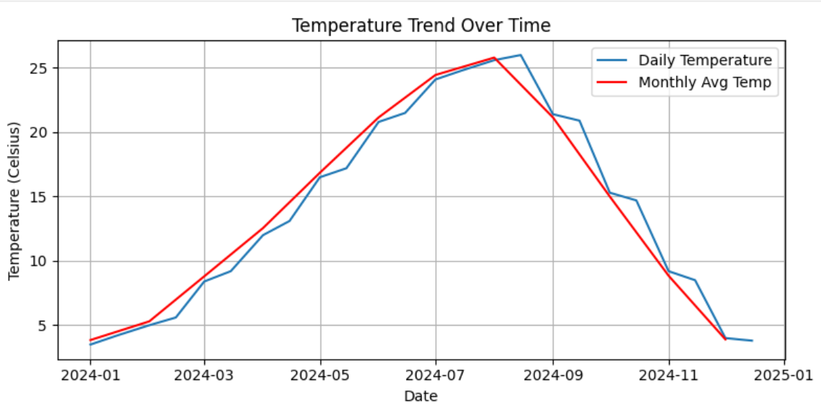

Dataset:

|  |  |  |
| --- | --- | --- |
| Date | Temperature (Celsius) | |
| 1/1/2024 | 3.5 |  |
| 1/15/2024 | 4.2 |  |
| 2/1/2024 | 5 |  |
| 2/15/2024 | 5.6 |  |
| 3/1/2024 | 8.4 |  |
| 3/15/2024 | 9.2 |  |
| 4/1/2024 | 12 |  |
| 4/15/2024 | 13.1 |  |
| 5/1/2024 | 16.5 |  |
| 5/15/2024 | 17.2 |  |
| 6/1/2024 | 20.8 |  |
| 6/15/2024 | 21.5 |  |
| 7/1/2024 | 24.1 |  |
| 7/15/2024 | 24.8 |  |
| 8/1/2024 | 25.6 |  |
| 8/15/2024 | 26 |  |
| 9/1/2024 | 21.4 |  |
| 9/15/2024 | 20.9 |  |
| 10/1/2024 | 15.3 |  |
| 10/15/202 | 14.7 |  |
| 11/1/2024 | 9.2 |  |
| 11/15/202 | 8.5 |  |
| 12/1/2024 | 4 |  |
| 12/15/202 | 3.8 |  |